**MANUSCRIPT**

**Modality Matters: Brain Age Derived from 18F-FDG-PET or MRI for Prediction of Cognitive Outcomes in the Early Alzheimer’s Disease Continuum**

E. Doering1,2, G. Antonopoulos3,5, M. Hönig1,4, T. van Eimeren1,2, M. Daamen², H. Boecker², S. B. Eickhoff3,5, K. R. Patil3,5, A. Drzezga1,2,4 for the Alzheimer’s Disease Neuroimaging Initiative[1]

1University Hospital Cologne, Clinic and Policlinic for Nuclear Medicine, Cologne, Germany, 2German Center for Neurodegenerative Diseases, Positron Emission Tomography, Bonn, Germany, 3Research Center Juelich, Brain and Behavior (INM-7), Juelich, Germany, 4 Research Center Juelich, Molecular Organization of the Brain (INM-2), Juelich, Germany, 5Heinrich-Heine-University, Institute of Systems Neuroscience, Duesseldorf, Germany

Corresponding author: E. Doering, Kerpener Str. 62, 50937 Köln, GERMANY, phone: (+49) 0221 478 7503, fax: (+49) 0221 748 7639, email: elena.doering@uk-koeln.de

Keywords: machine learning, cognitive impairment

Objectives: Brain aging is characterized by anatomical and molecular changes. Deviations from the normal aging trajectory in the form of advanced brain age relative to chronological age (“brain age gap”, *BAG*) is associated with various neurological abnormalities. Brain age is typically estimated from structural magnetic resonance imaging (MRI), however, changes in cerebral glucose metabolism, as detectable by 18F-Fluorodeoxyglucose positron emission tomography (FDG-PET), likely precede anatomical changes observed on MRI. Here, we compare the accuracy (mean absolute error, MAE) of brain age estimation from FDG-PET and structural MRI, and we associate BAG derived from both modalities with cognitive impairment and Alzheimer’s disease biomarkers. Furthermore, we present cutoffs for the prediction of cognitive outcome after two years. Analyses were conducted in individuals without (CN), with subjective cognitive decline (SCD) and with mild cognitive impairment (MCI).

Methods: Machine learning algorithms were trained to estimate brain age from 376 matched T1-weighted MRI or FDG-PET scans of CN from the Alzheimer’s Disease Neuroimaging Initiative using a nested cross-validation approach and validated in internal and external test sets. BAG was computed and correlated with measures of amyloid and tau pathology in CN and MCI (n=596). Finally, BAG was used to predict cognitive outcome after two years using cross-validated logistic regression. Cutoffs for cognitive decline were estimated from the logistic regression output.

Results: FDG-PET (MAE=2.46 years) and MRI (MAE=1.96 years) both predicted chronological age well. Both, FDG-PET- and MRI-derived BAG were correlated with amyloid load across groups and with cognitive performance in MCI. FDG-PET-derived BAG exceeding 0.85 years was indicative of pending cognitive impairment in CN/SCD, while an MRI-derived BAG beyond 2.23 years suggested development of dementia in MCI. BAG from the respective other modality was not/less indicative of cognitive outcome.

Conclusion:

Brain age is reliably estimated from FDG-PET or MRI. FDG-PET-derived BAG is more sensitive to early intracerebral changes related to the development of cognitive impairment in CN/SCD, while early features indicative of impending dementia in MCI are better reflected by MRI.

RUNNING TITLE: FDG-PET or MRI for Brain Age Estimation

**Graphical Abstract**

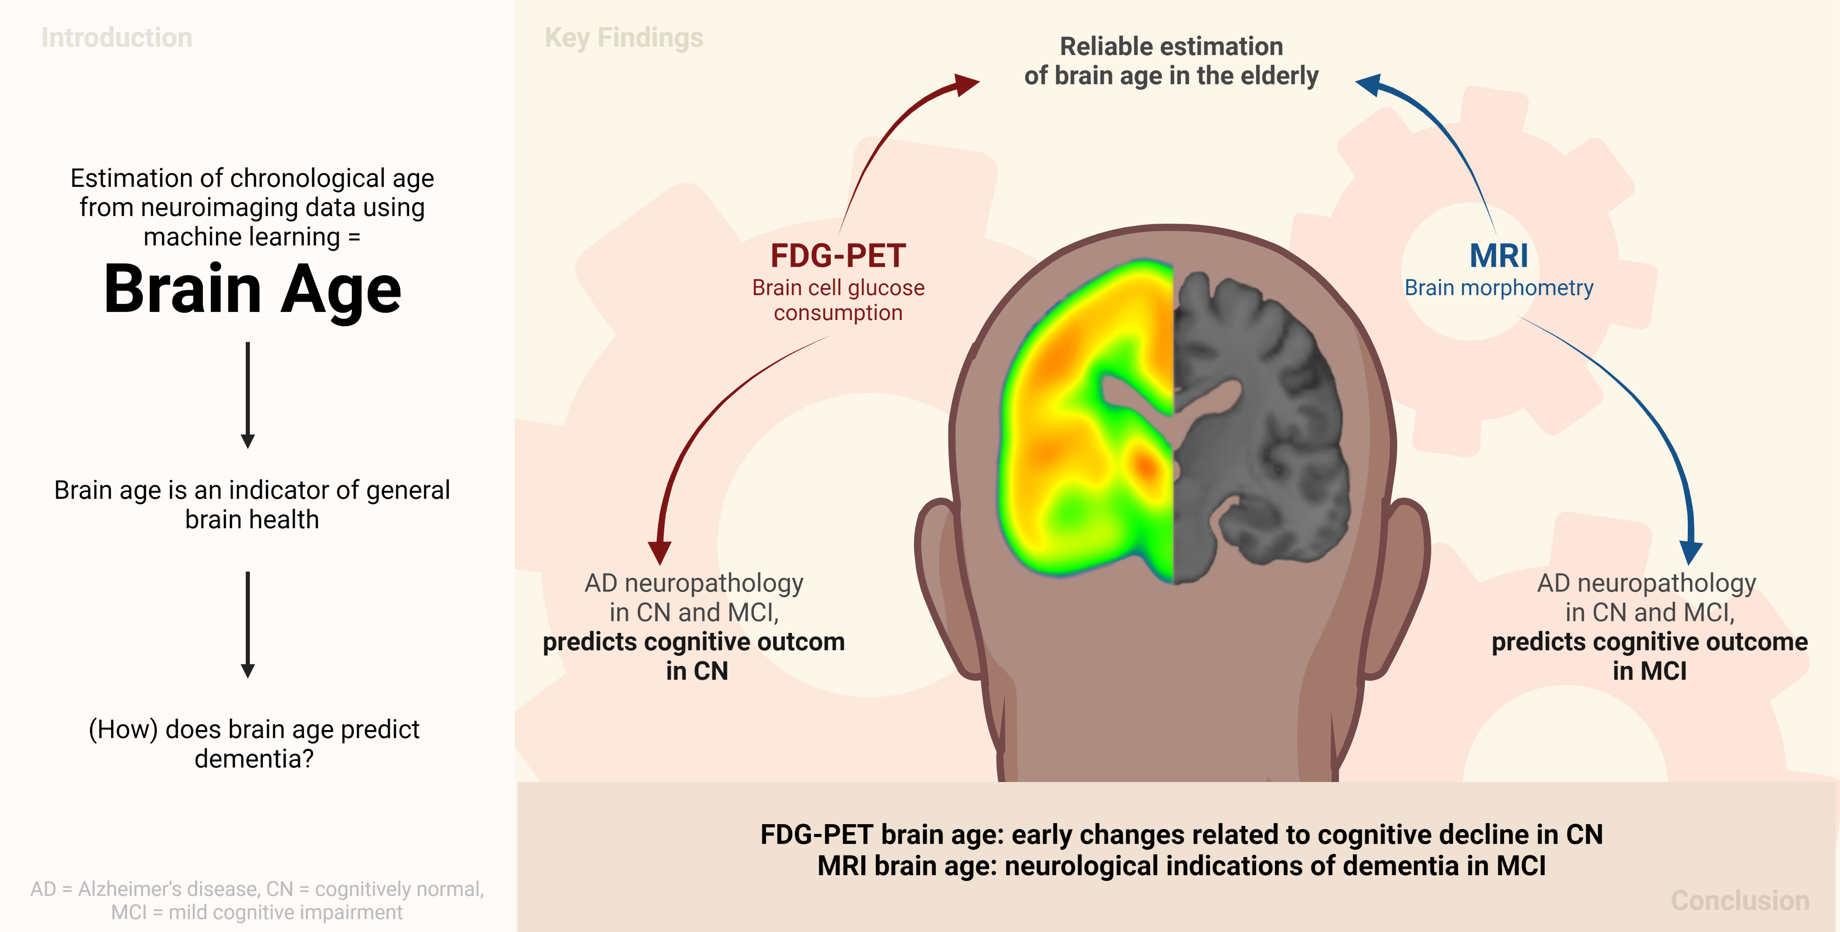

**1 Introduction**

Brain aging entails changes or decline in cognitive performance, accompanied by changes in various brain functions, as well as structural parameters of brain integrity. The age of the brain can be modeled using machine learning algorithms by predicting a person’s chronological age from their neuroimaging data. As such, brain age can provide a proxy of overall brain health. Deviations of brain age from chronological age indicate that the brain’s age is either advanced (a positive *brain age gap, “BAG”*) or delayed (a negative BAG), and it is associated with a variety of neurological conditions, including diagnoses across the Alzheimer’s disease (AD) continuum1–5. A recent study3 showed that BAG is not only different between patients with mild cognitive impairment (MCI) who will, or will not develop AD, but it is already substantially different between cognitively normal individuals who will develop cognitive impairment and those who will not. These results motivate further research into BAG as a prognostic biomarker of cognitive decline, as well as the relation between BAG and existing AD biomarkers, such as amyloid or tau pathology.

Age-related changes in the brain are most apparent from anatomical changes, such as loss of brain volume (atrophy), and molecular changes, such as a decline in neuronal metabolism (reflecting neuronal dysfunction). Brain atrophy can be quantified by T1-weighted magnetic resonance imaging (MRI) and cerebral glucose metabolism can be assessed by 18F-Fluorodeoxyglucose-PET (FDG-PET) *in vivo*. FDG-PET is usually considered to represent an earlier indicator of neurodegeneration compared to structural MRI, as it has been shown that atrophy (i.e., neuronal loss) is preceded by neuronal dysfunction6,7. Thus, it may be assumed that also processes associated with brain aging may be captured by FDG-PET with greater sensitivity compared to structural imaging. However, to date, the estimation of brain age is typically achieved using MRI rather than FDG-PET. Only one recent study compared FDG-PET with MRI for brain age estimation, and showed slightly better performance of brain age prediction when using FDG-PET3. However, in this study, FDG-PET was not investigated independently from MRI, as FDG-PET were preprocessed using partial volume correction, thereby possibly biasing the comparison to some extent. These findings argue for further exploration of FDG-PET-derived BAG, and its possibly superior performance in delineating the earliest deviations from normal aging when cognitive impairment is not yet apparent. Furthermore, no BAG cutoffs for the prognosis of cognitive impairment have yet been published but are critical for clinicians to make use of the information derived from brain age in a standardized way. Together, the above mentioned observations motivated this study.

Here, we aimed to investigate the potential of FDG-PET and MRI, independently, to serve as predictors of chronological age with a specific focus on the early stages of the AD continuum. First, we estimated brain age in cohorts of individuals who were cognitively normal (CN), or had subjective cognitive decline (SCD) and in cohorts of patients with mild cognitive impairment (MCI) using either FDG-PET or MRI. Second, we compared associations of FDG-PET- and MRI-derived BAG and cognitive performance/Alzheimer’s disease neuropathology in these cohorts. Finally, we applied machine learning classification to predict cognitive outcome from BAG, and subsequently calculated a cutoff for BAG for the prognosis of cognitive impairment.

**2 Method**

**2.1 Participants**

To train and test our algorithms for the estimation of brain age, baseline T1-weighted MRI and FDG-PET scans of 376 CN and SCD (*CN+SCDADNI*) and 596 individuals with MCI (*MCIADNI*) from the Alzheimer's Disease Neuroimaging Initiative (ADNI) database ([adni.loni.usc.edu](https://ida.loni.usc.edu/collaboration/access/adni.loni.usc.edu)) were used. To be included, participants had to be older than 60 years at the time of their scan. The primary goal of the ADNI study has been to test whether biological markers and clinical and neuropsychological assessments can be combined to measure the progression of MCI and dementia. Scans from the ADNI database were selected such that MRI and FDG-PET scans from the same individual were not more than one year apart for unbiased comparison of the modalities (CN+SCD: mean = 31 days, SD = 29 days[2]; MCI: mean = 29 days, SD = 25 days). An additional 59 MRI and FDG-PET scans of CN were acquired from the Open Access of Imaging Studies-3 (OASIS-3, https://www.oasis-brains.org/8, *CNOASIS*) database to validate brain age estimation models in an external dataset. Finally, 80 MRI scans of MCI (MCIDELCODE)and 88 FDG-PET scans of SCD (SCDDELCODE) from the DZNE-Longitudinal Cognitive Impairment and Dementia Study (DELCODE)9 were employed to validate our prediction models for cognitive outcome. To be included, participants from all samples had to be older than 60 years at the time of their scan.

CN, SCD and MCI diagnoses from ADNI, OASIS, and DELCODE followed the current recommendations for the respective groups10,11. CN individuals had no significant impairment in memory or cognitive functions or activities of daily living, and no significant memory concern. Individuals with SCD (*SCD,* n = 106) were also included in this cohort. To be considered SCD, either the study participant, an informant, or the clinician (ADNI)/the study participant (DELCODE) reported a significant memory concern in the absence of objective impairment of memory of cognitive function. An MCI diagnosis was provided to individuals with measurable impairment in cognitive function in the absence of dementia or significant impairments of daily living.

**2.2 Acquisition & Preprocessing of Biomarkers of Neurodegeneration**

FDG-PET scans in ADNI and OASIS were acquired dynamically 30-60 minutes (6x5 min frames) after injection with an average dose of 185 MBq (5 mCi). The DELCODE FDG-PET data were acquired 40-60 minutes (4x5 min frames) after injection with an average dose of 170-180 MBq. Preprocessing was performed on average scans of the given time intervals using the Statistical Parametric Mapping 12 toolbox (SPM12; [www.fil.ion.ucl.ac.uk](http://www.fil.ion.ucl.ac.uk)) in MATLAB (r2021b, The MathWorks Inc). All FDG-PET scans were aligned to the anterior commissure/posterior commissure, and subsequently co-registered and normalized to a template in standard MNI152 space. Finally, standardized uptake value ratios (SUVRs) were calculated (reference: pons12).

T1-weighted MRI scans were acquired according to published MRI acquisition protocols8,9,13. Scans were preprocessed using the CAT toolbox (version 12.5) in SPM12 based on MATLAB (r2019b): First, we applied denoising (spatial-adaptive Non-Local Means), spatial registration, bias correction and skull striping. Subsequently, scans were segmented by an adaptive maximum a posteriori approach14 with a partial volume model15. For non-linear transformation, the Geodesic Shooting Algorithm16 was used.

**2.3 Estimation of brain age**

To estimate brain age, we implemented a pipeline (**Fig 1)** in Python 3.8.5 using the Julearn library (<https://juaml.github.io/julearn/main/index.html>), which in turn is based on scikit-learn17. The same pipelines were run independently for FDG-PET and MRI. First, regional averages of the signal of interest were extracted for the respective modality (FDG-PET: SUVR, MRI: gray matter volume) using a composite atlas containing 200 cortical18 and 16 subcortical regions19. Next, we applied a nested cross-validation approach: We repeatedly (five times) split the CN sample into different training and test sets, such that each individual occurred in a test set exactly once. Through stratification, the original proportions of young-old (65 - 74 years, ~52% of our sample), middle-old (75 - 84 years, ~40% of our sample) and oldest-old individuals (85 years+, ~8% of our sample)20 in the CN+SCDADNI sample were maintained in each training and test set. Each outer cross-validation loop consisted of outlier exclusion, an inner cross-validation yielding of a final model, estimation of parameters for bias correction21, estimation of brain age in the test sets, and application of bias correction to the respective CN+SCDADNI test set, as well as the other cohorts.

**2.3.1 Outlier exclusion**

Outlier exclusion was performed in the outer cross-validation loop to ensure data quality in an automated manner. Interquartile ranges (IQRs) were inferred from the CN+SCDADNI training sets. Subjects outside 6xIQR were removed from the training and respective CN+SCDADNI test, OASISCN and SCDDELCODE sets. Importantly, as previous works have shown, MCI subjects show an advanced brain age, which likely translates to a reduced signal in age-relevant brain regions5. Thus, outlier exclusion was not applied to the MCI samples.

**2.3.2 Inner cross-validation**

The inner cross-validation procedure was performed for hyperparameter tuning and yielded five ‘final models’. Two types of algorithms previously recommended for small sample sizes22 were implemented for brain age prediction: support vector regression (SVR) and relevance vector regression (RVR). Hyperparameter tuning was performed using five-fold stratified cross-validation on both kinds of models (for a list of hyperparameters, see Supplementary Materials Section Methods - Hyperparameters). During each iteration of the inner cross-validation, four parts of the training data were first scaled (by removing the median and scaling the data according to the IQR, “robust scaler” from the scikit-learn library). The estimated scaling parameters were subsequently applied to the fifth part of the training data, i.e., the validation set. Subsequently, RVR and SVR were trained using the training data and evaluated on the validation data. As a result of the inner cross-validation, one optimal RVR and one optimal SVR were yielded, where “optimal” refers to the respective hyperparameter configuration that allowed for the smallest average mean absolute error (MAE) between CA and BPA across the validation sets. From the two optimal models, the final model was then selected as the model with the smallest average MAE on the validation data.

**2.3.3 Bias correction**

Brain age is subject to a frequently reported bias, in which the brain age of older individuals is under- and the brain age of younger individuals is overestimated21, regardless of the data or method under consideration23. Here, bias correction parameters were estimated using a linear model21 in the validation set, and subsequently applied to all test sets. The final brain age was calculated using slope (ɑ) and an intercept (β) as follows:

**2.3.4 Precision of brain-predicted age and brain age gap**

As a result of the nested cross-validation approach described above, we obtained five final models per modality. Thus, per modality, we obtained one prediction per (non-outlier) subject in the CN sample (n = 357), and five predictions per (non-outlier) subject in the CNOASIS (n = 52), SCDDELCODE (n = 88), MCIADNI (n = 596), and MCIDELCODE sample (n = 80). In the CNOASIS, SCDDELCODE, MCIADNI and MCIDELCODE sample, the average of all five brain age predictions was treated as the final brain age (‘bagging’). The feature importance (δ) of each brain region was assessed by considering the learned weights of models with a linear kernel. For non-linear kernels, weight coefficients cannot be directly inferred. Regions were considered ‘highly important’ for brain age estimation, if their weight coefficient was smaller than the mean – 2 standard deviations (SD), or larger than the mean + 2SD of all brain regions. Finally, for each individual, BAG was calculated as the difference between brain age and chronological age, such that a positive BAG indicated higher brain age compared to chronological age.

**2.4 Associations of brain age gap with cognitive performance and Alzheimer’s disease neuropathology**

To assess whether BAG is associated with cognitive performance, we calculated partial correlations between BAG and composite scores of memory (ADNI-MEM24) and executive function (ADNI-EF25) while correcting for age, sex, years of education and APOE-ε4 carriership status. The correlations were tested against a Bonferroni-corrected α-level of .025 (0.05/2). The ADNI-MEM combines several scores used to evaluate individuals’ memory performance from the Rey Auditory Verbal Learning Test, Alzheimer’s Disease Assessment Scale and Mini Mental State Exam. The ADNI-EF is a summary score of several executive function tasks: Category Fluency, Trails, Digit span backwards, Wechsler Adult Intelligence Scale-R Digit Symbol Substitution, Number Cancellation, and Clock Drawing items. These correlations were computed exclusively in the ADNI samples.

To assess whether BAG is associated with AD neuropathology, we calculated partial correlations between BAG and PET amyloid load (AV45-PET), as well as markers of beta-amyloid1-42 (CSF Aβ1-42), total tau (CSF Tau) and phosphor-tau181p (CSF p-Tau181) in cerebrospinal fluid (CSF), while correcting for age, sex, years of education and APOE-ε4 carriership. The Bonferroni-corrected α-level was set to 0.0125 (0.05/4). For AV45-PET, mean SUVR are publicly available from previous analyses26–29. CSF measures of amyloid, tau and phospho-tau were acquired via lumbar puncture and analyzed using the Roche Elecsys® immunoassays30. The number of tau PET scans already evaluated for SUVR in the current cohorts was too small to include this biomarker in the current analyses. Again, these correlations were computed exclusively in the ADNI samples.

**2.5 Prediction of cognitive outcome using the brain age gap**

Finally, we trained a logistic regression classifier to predict cognitive outcome within two years from baseline (where BAG was assessed). The classifier was trained and tested in the ADNI samples, and the derived threshold was subsequently evaluated in the DELCODE cohorts. Cognitive outcome was a binary variable (“stables” vs. “decliners”), based on the final diagnosis at the two year follow-up visit. CN who received a diagnosis of MCI or AD *within two years* were labeled as cognitive *decliners*, while CN who maintained the CN status *until 24 months after BAG assessment* were labeled as *stables*. For MCI, decliners were those individuals who progressed to dementia within two years, while individuals who maintained the MCI diagnosis until 24 months after BAG assessment were considered stable. In the ADNI study, a diagnosis of dementia at follow-up entailed the presence of dementia symptoms, abnormal memory and cognitive function and fulfillment of NINCDS/ADRDA criteria for probable AD. In DELCODE, a diagnosis of dementia at follow-up required fulfillment of the NINCDS/ADRDA criteria for possible or probable AD. MCI patients who were diagnosed as CN after two years were disregarded in the current analyses (n=29). Both in CN and MCI, we extracted an equally-sized subsample of stables, matched by age and sex to the complete cohort of decliners. MRI- and FDG-derived BAG in these samples, together with amyloid status (CSF amyloid1-42 <= 1100 pg/ml31), APOE-ε4 carriership and years of education, were used as input to predict cognitive outcome using a 10-fold cross-validated logistic regression classifier, as depicted in **Fig 2**. As amyloid status was not available for all individuals, analyses were conducted in two ways: once including individuals with missing amyloid information (NA values coded as 0, and amyloid negativity coded as reference; “whole samples”) and once excluding individuals with missing amyloid information (“complete samples”). Significant predictors (α=.05) of cognitive outcome were recorded. To derive a BAG cutoff for elevated risk of a change in cognitive diagnosis, a logistic regression was fitted to model the relationship between BAG from the significant BAG and cognitive outcome. The intercept of this curve at 50% probability was set as a cutoff and validated in the current (ADNI), as well as the DELCODE sample.

**3 Results**

**3.1 Participants**

This study included 972 MRI and FDG-PET scans (respectively) from the ADNI database (CN+SCDADNI: n = 376; MCIADNI: n = 596). To validate brain age estimation, we used 59 MRI and FDG-PET scans (respectively) of CN from the OASIS-3. To validate BAG cutoffs for the prediction of cognitive outcome, we used 88 FDG-PET scans of SCD and 80 MRI scans of MCI patients from the DELCODE study. An overview of participant characteristics is presented in **Table 1**. In the cognitively unimpaired cohorts, CNOASIS and SCDDELCODE were significantly younger than CN+SCDADNI (tOASIS = 3.44, *p*OASIS < .001; tDELCODE = 4.45, *p*DELCODE < .0001), and the MMSE of SCDDELCODE was higher compared to CN+SCDADNI (tDELCODE = -2.30, *p* = .03). Among MCI samples, MCIDELCODE had significantly fewer years of education (t = 6.01, *p* < .001)

**3.2 Accuracy and demographic profile of brain-predicted age**

In the CN+SCDADNI group (n = 357 after outlier exclusion, test predictions), MRI and FDG-PET predicted chronological age with an MAE of 1.96 and 2.63 years, and a broad range of BAG spanning 16 and 18.7 years, respectively (see **Table 2**). The MAE of MRI-derived brain age was significantly lower compared to FDG-PET (paired t-test, t = -6.69, p = .026). In CN+SCDADNI, MRI- and FDG-PET-derived BAG were normally distributed and moderately correlated across modality (r = .288, *p* < 0.001). In the external CNOASIS sample (n=52 after outlier exclusion), final (bagged) estimations of brain age had an MAE of 2.23 and 2.03 years for MRI and FDG-PET, respectively, thus showing high generalization of the models to an external dataset. The brains of individuals from SCDDELCODE were estimated from FDG-PET to be, on average, 2.07 years advanced in age compared to their chronological age. MCIADNI individuals’ brains were estimated to be, on average, 1.51 or 1.07 years advanced in age when predicted from MRI or FDG-PET. In MCIADNI, BAG was normally distributed when derived from MRI, but not from FDG-PET, and it was strongly correlated across modality (rho =.428, *p* < .001). MCIDELCODE individuals’ brains were estimated to be 1.42 years older on MRI than their chronological age. Bias correction eliminated the correlation between BAG and chronological age in the CN+SCDADNI, CNOASIS, and DELCODEsamples, although a trend-level (α=0.1) correlation remained between BAG and chronological age in the CNOASIS sample (MRI: r = -.242, *p* = .08, FDG-PET: r = .266, *p* = 0.06).

Women showed lower BAG than men in CN+SCDADNI (tMRI = -6.98, *pMRI* < .0001, tFDG-PET = -1.98, *pFDG-PET* = .05), SCDDELCODE (tFDG-PET = -2.13, *p* = 0.04), MCIADNI (tFDG-PET = -3.85, *pFDG-PET* < .001; tMRI = -5.58, *pMRI* < .0001), and MCIDELCODE (tMRI = -2.73, *pMRI* < .008), especially on MRI-derived BAG. Carriership of the APOE-ε4 allele, genetically predisposing for Alzheimer’s disease, was associated with higher BAG in MCIADNI (only MRI: tMRI = 2.72, *pMRI*= 0.007). Years of education was not correlated with BAG in any of the samples.

Model selection returned linear SVRs five out of five and four out of five times for MRI and FDG-PET, respectively. To assess the feature importance of brain age estimation in the two modalities, we extracted all brain regions’ weights as learned by these models. Regional weight coefficients were strongly correlated across models of the same modality (MRI: r = [.79, 0.89], FDG-PET: r = [.74, .79]), but average weight coefficients were not correlated between the two modalities (r = .048, *p* = .48), i.e. the regions used for brain age prediction in the two modalities were substantially different (see **Fig 3**). For FDG-PET (range of weight coefficients δ: [-0.99 (right globus pallidus), 1.04 (right caudate nucleus)]), important regions (very low or very high weight coefficient) included parts of the temporal and pre-frontal cortex, as well as sub-cortical regions (globus pallidus, nucleus accumbens, and caudate nucleus). Notably, SUVR in all nine highly important regions in FDG-PET (mean(δ) + 2SD(δ) > δ < mean(δ) - 2SD(δ)) were right hemispheric, and negatively correlated with chronological age after Bonferroni correction (α=.05/9). For MRI (range: [-0.30 (right hippocampus), 0.22 (right visual network)]), important regions included parts of the parietal, pre-frontal and occipital cortex and sub-cortical regions (e.g., hippocampus, nucleus accumbens, globus pallidus, and caudate nucleus). Out of 13 highly important regions for brain age estimation from MRI, nine were negatively correlated with age after Bonferroni correction (α=.05/13). A full list of highly important regions with correlation results can be found in the Supplementary materials, section Results - Feature Importance.

**3.3 BAG and cognitive performance**

In CN, ADNI-MEM (*p* =.64) and ADNI-EF (*p* =.13) scores were normally distributed as assessed with the Shapiro-Wilk test; hence, Pearson correlations were computed. Higher MRI-derived BAG was associated with lower ADNI-EF scores (r =-.137, *p*=.01). A marginally significant correlation was observed between FDG-PET-derived BAG and ADNI-MEM scores (r =-.100, *p* =.06).

In MCI, ADNI-MEM (*p* =.004) and ADNI-EF (*p* =.05) were not normally distributed as assessed with the Shapiro-Wilk test; thus, Spearman-rank correlations were assessed. Both, MRI- and FDG-PET-derived BAG were negatively correlated with ADNI-MEM (rhoMRI =-.379, *pMRI <*.0001; rhoFDG-PET =-.237, *pFDG-PET* <.0001) and ADNI-EF (rhoMRI =-.272, *pMRI <*.0001; rhoFDG-PET =-.243, *pFDG-PET*  <.0001).

**3.4 BAG and AD neuropathology**

In CN+SCDADNI, higher MRI- and FDG-PET-derived BAG were both correlated with a decrease in CSF Aβ1-42 (rhoMRI =-.152, *pMRI* =.012; rhoFDG-PET =-.152, *pFDG-PET* =.012), but none of the other pathological variables. In MCIADNI, both, higher MRI- and FDG-PET-derived BAG were associated with enhanced amyloid accumulation, as reflected by significant negative correlations with CSF Aβ1-42 (rhoMRI = -.232, *pMRI <*.0001; rhoFDG-PET = -.144, *pFDG-PET* =.002) and (marginal) positive correlations with global AV45 (rhoMRI =.144, *pMRI* =.004; rhoFDG-PET =.110, *pFDG-PET* =.026). Moreover, higher MRI-derived BAG was marginally associated with higher levels of CSF pTau181 (rhoMRI =.093, *pMRI* =.048).

**3.5 BAG and Cognitive Outcome**

In the CN+SCDADNI sample, 278 individuals remained stable until year two, while 30 obtained a diagnosis of cognitive impairment (MCI or dementia) within two years. Consequently, a subsample of 30 stables and all 30 decliners constituted the subsample for the prediction of cognitive outcome in CN. We found that, holding all other predictor variables constant, FDG-PET-derived BAG and APOE-ε4 carriership significantly predicted cognitive outcome at year two follow-up. The odds of a cognitive impairment diagnosis within two years were increased by 29% (95% CI [1.079, 1.604], *p* = .010) for every FDG-PET-derived BAG year. Moreover, the odds of developing cognitive impairment were increased by eightfold with a positive APOE-ε4 carriership status (95% CI [1.496, 71.814], *p* = .028). To obtain a cutoff for prognoses of cognitive impairment, we fitted a logistic regression model on cognitive outcome by BAG on FDG-PET. The intersection of the curve with a 50% probability of receiving such a diagnosis was at 0.85 years FDG-PET BAG (see **Fig. 4**). This suggests that cognitively unimpaired individuals with a brain age advanced by 0.85 years have an elevated risk of converting to cognitive impairment. In the current CN+SCDADNI subsample, stratification by this cutoff yielded a sensitivity of 70% and a specificity of 67% (positive predictive value *PPV* = 68%, negative predictive value *NPV* =

69%). To validate the cutoff in an external dataset, we applied it to the SCDDELCODE cohort (ndecliners= 8, nstables = 80), where we obtained a sensitivity of 88% and a specificity of 34% (PPV = 13%, NPV = 96%).

After removing those individuals who did not have information on amyloid status available (n=6), a “complete” sample of 24 decliners remained, thus constituting a sample size of 48. The results from the complete samples were consistent with those obtained from the whole samples and can be found in the Supplementary Materials, section “Prediction of Cognitive Outcome”.

Three hundred forty eight MCI patients remained stable until year two, while 113 MCI patients converted to dementia. Consequently, a subsample of 113 stables and all 113 decliners constituted the subsample for prediction of cognitive outcome in MCI. Holding all other predictor variables constant, MRI-derived BAG, a positive amyloid status in CSF, and APOE-ε4 carriership significantly predicted cognitive outcome after two years. With every one-year increase in BAG on MRI, the odds of converting to MCI or dementia were increased by 52% (95% CI [1.304, 1.788]), while a positive amyloid status and APOE-ε4 carriership increased those odds by four- (95% CI [1.632, 11.255]) and threefold (95% CI [1.495, 6.254]), respectively. To obtain a cutoff for cognitive outcome, we fit a logistic regression model on cognitive outcome by MRI BAG. The intersection of the curve with a 50% probability of receiving such a diagnosis was at 2.14 years of MRI BAG (see **Fig. 5**). Again, this suggests that if the brain age of an MCI patient is advanced by at least this cutoff value, they have an elevated risk of converting to dementia. In the current MCIADNI subsample, stratification by this cutoff yielded a sensitivity of 73% and a specificity of 72% (PPV = 72%, NPV = 73%). In the MCIDELCODE sample (nstables = 41, ndecliners = 28), the cutoff had a sensitivity of 68% and a specificity of 73% (PPV = 63%, NPV = 79%).

Three hundred sixty nine MCI patients had full information for all considered variables, thus constituting the decliner group of the complete samples. The results from the complete samples were consistent with those obtained from the whole samples and can be found in the Supplementary Materials. Finally, given the moderate and strong correlation observed between FDG-PET- and MRI BAG in CN+SCDADNI and MCIADNI (see Section 3.2), we assessed logistic regression models with unimodal BAG32. Considered in separate models, both MRI- and FDG-PET-BAG significantly predicted cognitive outcome in MCIADNI, while only FDG-PET predicted cognitive outcome in CN+SCDADNI (see Supplementary Materials, Section Cognitive Outcome, Tables S2-S5 for estimates of logistic regression in whole samples).

**4 Discussion**

Previous studies have mostly used MRI to estimate brain age. FDG-PET is an early indicator of neurodegeneration-associated cerebral changes and a recent study showed for the first time that it could also be successfully used to estimate brain age3. Here, we compared the accuracy of FDG-PET and MRI-estimated brain age and provided a comprehensive overview of the cognitive and neuropathological profile of FDG-PET and MRI-derived BAG in different cognitive groups. We showed that 1) MRI and FDG-PET both predict chronological age accurately, 2) MRI and FDG-PET-derived BAG both reflect neuropathological abnormalities in CN/SCD and MCI, as well as cognitive dysfunction in MCI, and 3) BAG derived from FDG-PET yields prognoses of cognitive outcome in CN/SCD, while MRI does the same in MCI. We further computed and validated cutoffs for the prognosis of cognitive impairment. XX WHAT’S GREAT ABOUT THIS STUDY XX

Congruent with previous work, our findings suggest that FDG-PET shows greater and more consistent changes related to early and subtle neurodegeneration-associated changes in the brain as observed in cognitively unimpaired individuals. MRI, on the other hand, was superior in delineating dementia-related changes in MCI7. Among the CN population, our results are likely most relevant for individuals experiencing SCD, who are 1) assumed to recognize cognitive deficits before they become clinically measurable10, 2) more likely to develop MCI or AD compared to CN33, and 3) likely to be seen by a physician compared to CN given their subjective symptoms. The prediction of cognitive outcome in this cohort based on FDG-PET BAG was moderately to highly sensitive with moderately to very high NPV, while the specificity and PPV was low. Consistently, Lee and colleagues showed that FDG-PET BAG is significantly increased in CN converting to MCI or AD at baseline3. Together, these findings deliver strong evidence that FDG-PET BAG could complement the identification of at-risk individuals, as individuals with a BAG below our proposed cutoff are less likely to develop cognitive impairment within two years.

The inclusion of BAG into clinical trials of AD could have several advantages. Numerous anti-amyloid therapies are currently under assessment or have recently been approved for the treatment of MCI and early AD. Since cognitive decline is often an outcome factor of these trials, a BAG cutoff could help identify those individuals who are at higher risk of cognitive decline, thereby aiding in reducing the number of participants and thus the cost and time of treatment trials. Moreover, BAG is an established summary marker of brain health34 and reflects various neurological abnormalities beyond AD35,36. In line with that, beyond its prognostic value, we have shown that BAG is associated with amyloid load, regardless of modality or group, and that in MCI, both MRI and FDG-PET BAG depict impairment of memory and executive function. The inclusion of BAG as a summary measure of overall brain health as an additional outcome variable could provide useful information on drug efficacy.

Similar to previous studies3,7, we found a spatial disconnect between brain regions displaying aging as observed on FDG-PET and MRI. Thus, different aging processes may be observed depending on the modality, which underlines the importance of consideration of the appropriate modality for a research question. The (mostly right hemispheric) regions deemed most important by our MRI and FDG-PET models have previously been described to be substrates heavily affected by aging7, and most of the regions we identified as highly important were strongly correlated with age in our cohort. Notably, most of the highly age-affected brain regions on MRI and all on FDG-PET were right hemispheric, thus substantiating the idea that the right hemisphere exhibits greater age-related decline37,38. Moreover, temporal, parietal, and prefrontal regions are strongly affected by AD39. Since these regions were also highly relevant in estimating brain age by our current models, our work supports the claim that AD-related neurodegeneration, at least in part, resembles a form of advanced brain aging. However, it is also possible that the right hemisphere dominance was due to multi-collinearity, i.e. the models chose right hemispheric regions instead of their correlated left-hemispheric counterparts. To disentangle hemispheric dominance in brain aging is thus an important question for future research.

Some limitations should be acknowledged. First, the sensitivity and especially specificity values of FDG-PET BAG for prognoses in cognitively unimpaired individuals, as well as of MRI BAG for prognoses in MCI patients, are not high enough for these measures to be used as stand-alone biomarkers of cognitive outcome. However, accurate prognoses, especially for cognitively unimpaired individuals, are difficult to establish and we believe that brain age assessment with a group-dependent choice of modality can support this process. Future work should assess the combined potential of FDG-PET BAG and APOE-ε4 carriership as a prognostic biomarker of cognitive outcome. Such analysis was not possible with our current data, as it would have introduced data leakage, and thus, biased predictions. Unfortunately, multimodal datasets containing FDG-PET data are rare. Future data collection of datasets comprising such data will be helpful in advancing research on BAG as a biomarker of cognitive outcome. Second, the different scan protocol of DELCODE FDG-PET data (acquisition time: 40-60 min post injection) compared to ADNI and OASIS (acquisition time: 30-60 min post injection) could possibly have influenced the generalization performance of our models to the DELCODE cohort. Yet, we believe that the difference would not be substantial with an equal acquisition time, given that we averaged time frames over the whole acquisition time. Third, it is not a straightforward task to acquire FDG-PET scans from a CN/SCD population, as it requires logistic availability, comparably high cost, and the injection of a radioactive tracer in the absence of an objective indication of cognitive impairment. However, especially for an SCD population, where prognoses are not yet otherwise available, BAG assessment via FDG-PET might be useful to deliver a first indicator of cognitive outcome. FDG-PET as a marker of neuronal activity may also be substituted by other imaging procedures such as early perfusion phase amyloid-PET or tau-PET acquisition. It remains to be demonstrated if these methods similarly allow BAG assessment. Whether the multidimensional feature space of FDG-PET can be replaced by easily accessible fluid biomarkers of neurodegeneration and whether they would accurately reflect brain age, is debatable and an intriguing matter for future research. Fourth, the average BAG (ME) of SCDDELCODE exceeds previously reported BAG on MRI (1.1 years2), as well as MRI and FDG-PET BAG of MCI patients in our analyses. These differences may be driven by a combination of factors, including a different choice of modality, as we, for the first time, used FDG-PET to estimate brain age in an SCDcohort. Whether the FDG-PET BAG is abnormally high in our analyses, or whether higher FDG-PET BAG in SCD reflects very early neurological dysfunction needs further investigation. Finally, our definition of CN only required the absence of objective cognitive impairment but not normality according to specific biomarkers. Thus, participants with and without underlying amyloid pathology may have been included in our training sample, which possibly introduced a confound. However, we chose to train our models to capture the pathological heterogeneity of cognitively normal individuals to obtain a realistic estimate of brain aging.

In conclusion, we have shown that FDG-PET and MRI can both be used for brain age prediction and show different advantages depending on the analyzed group: While both MRI- and FDG-PET BAG accurately reflect neuropathological burden across groups and cognitive performance in MCI, FDG-PET BAG can support the prognosis of cognitive outcome in cognitively unimpaired individuals. BAG on MRI, on the other hand, proves better estimation for risk of dementia in MCI. Estimation of cognitive outcome by means of our BAG cutoffs could complement the identification of patients in need of frequent monitoring at an early time point of cognitive decline, as well as support clinical trials, both methodologically and financially.

**Statements & Declarations**

**Author Contributions**

All authors contributed to the study conception and design. Material preparation, data collection and analysis were performed by ED and GA, in support of KP and MH. KP, TvE, SE and AD jointly supervised this work. DELCODE data was provided by MD and HB. The first draft of the manuscript was written by ED and all authors commented on previous versions of the manuscript. All authors read and approved the final manuscript.

**COMPETING INTERESTS**

MH reports no conflict of interest.

**Funding**

KRP and SBE were partly supported by the Deutsche Forschungsgemeinschaft (DFG, PA 3634/1-1 and EI 816/21-1).

Data collection and sharing for this project was funded by the Alzheimer's Disease Neuroimaging Initiative (ADNI) (National Institutes of Health Grant U01 AG024904) and DOD ADNI (Department of Defense award number W81XWH-12-2-0012). ADNI is funded by the National Institute on Aging, the National Institute of Biomedical Imaging and Bioengineering, and through generous contributions from the following: AbbVie, Alzheimer's Association; Alzheimer's Drug Discovery Foundation; Araclon Biotech; BioClinica, Inc.; Biogen; Bristol-Myers Squibb Company; CereSpir, Inc.; Cogstate; Eisai Inc.; Elan Pharmaceuticals, Inc.; Eli Lilly and Company; EuroImmun; F. Hoffmann-La Roche Ltd and its affiliated company Genentech, Inc.; Fujirebio; GE Healthcare; IXICO Ltd.;Janssen Alzheimer Immunotherapy Research & Development, LLC.; Johnson & Johnson Pharmaceutical Research & Development LLC.; Lumosity; Lundbeck; Merck & Co., Inc.;Meso Scale Diagnostics, LLC.; NeuroRx Research; Neurotrack Technologies; Novartis Pharmaceuticals Corporation; Pfizer Inc.; Piramal Imaging; Servier; Takeda Pharmaceutical Company; and Transition Therapeutics. The Canadian Institutes of Health Research is providing funds to support ADNI clinical sites in Canada. Private sector contributions are facilitated by the Foundation for the National Institutes of Health ([www.fnih.org](https://ida.loni.usc.edu/collaboration/access/www.fnih.org)). The grantee organization is the Northern California Institute for Research and Education, and the study is coordinated by the Alzheimer's Therapeutic Research Institute at the University of Southern California. ADNI data are disseminated by the Laboratory for Neuro Imaging at the University of Southern California.

**References**

1. Beheshti, I., Mishra, S., Sone, D., Khanna, P. & Matsuda, H. T1-weighted MRI-driven brain age estimation in Alzheimer’s disease and Parkinson’s disease. *Aging Dis.* **11**, (2020).

2. Rokicki, J. *et al.* Multimodal imaging improves brain age prediction and reveals distinct abnormalities in patients with psychiatric and neurological disorders. *Hum. Brain Mapp.* **42**, (2021).

3. Lee, J. *et al.* Deep learning-based brain age prediction in normal aging and dementia. *Nat. Aging* (2022) doi:10.1038/s43587-022-00219-7.

4. Löwe, L. C., Gaser, C. & Franke, K. The effect of the APOE genotype on individual BrainAGE in normal aging, Mild cognitive impairment, and Alzheimer’s Disease. *PLoS One* **11**, (2016).

5. Gaser, C., Franke, K., Klöppel, S., Koutsouleris, N. & Sauer, H. BrainAGE in Mild Cognitive Impaired Patients: Predicting the Conversion to Alzheimer’s Disease. *PLoS One* **8**, (2013).

6. Jack, C. R. *et al.* Hypothetical model of dynamic biomarkers of the Alzheimer’s pathological cascade. *The Lancet Neurology* vol. 9 119–128 (2010).

7. Dukart, J. *et al.* Generative FDG-PET and MRI Model of Aging and Disease Progression in Alzheimer’s Disease. *PLoS Comput. Biol.* **9**, e1002987 (2013).

8. LaMontagne, P. J. *et al.* OASIS-3: Longitudinal neuroimaging, clinical, and cognitive dataset for normal aging and Alzheimer disease. *medRxiv* (2019) doi:10.1101/2019.12.13.19014902.

9. Jessen, F. *et al.* Design and first baseline data of the DZNE multicenter observational study on predementia Alzheimer’s disease (DELCODE). *Alzheimer’s Res. Ther.* **10**, (2018).

10. Jessen, F. *et al.* A conceptual framework for research on subjective cognitive decline in preclinical Alzheimer’s disease. *Alzheimer’s Dement.* **10**, (2014).

11. Albert, M. S. *et al.* The diagnosis of mild cognitive impairment due to Alzheimer’s disease: Recommendations from the National Institute on Aging-Alzheimer’s Association workgroups on diagnostic guidelines for Alzheimer’s disease. *Alzheimer’s Dement.* **7**, 270–279 (2011).

12. Verger, A., Doyen, M., Campion, J. Y. & Guedj, E. The pons as reference region for intensity normalization in semi-quantitative analysis of brain 18FDG PET: application to metabolic changes related to ageing in conventional and digital control databases. *EJNMMI Res.* **11**, 1–7 (2021).

13. Jack, C. R. *et al.* The Alzheimer’s Disease Neuroimaging Initiative (ADNI): MRI methods. *Journal of Magnetic Resonance Imaging* vol. 27 (2008).

14. Rajapakse, J. C., Giedd, J. N. & Rapoport, J. L. Statistical approach to segmentation of single-channel cerebral mr images. *IEEE Trans. Med. Imaging* **16**, (1997).

15. Tohka, J., Zijdenbos, A. & Evans, A. Fast and robust parameter estimation for statistical partial volume models in brain MRI. *Neuroimage* **23**, (2004).

16. Ashburner, J. & Friston, K. J. Diffeomorphic registration using geodesic shooting and Gauss-Newton optimisation. *Neuroimage* **55**, (2011).

17. Pedregosa, F. *et al.* *Scikit-learn: Machine Learning in Python Gaël Varoquaux Bertrand Thirion Vincent Dubourg Alexandre Passos PEDREGOSA, VAROQUAUX, GRAMFORT ET AL. Matthieu Perrot*. *Journal of Machine Learning Research* vol. 12 http://scikit-learn.sourceforge.net. (2011).

18. Schaefer, A. *et al.* Local-Global Parcellation of the Human Cerebral Cortex from Intrinsic Functional Connectivity MRI. *Cereb. Cortex* **28**, (2018).

19. Tian, Y., Margulies, D. S., Breakspear, M. & Zalesky, A. Hierarchical organization of the human subcortex unveiled with functional connectivity gradients. *bioRxiv* (2020) doi:10.1101/2020.01.13.903542.

20. Suzman, R. & Riley, M. W. Introducing the ‘oldest old’. *Milbank Mem. Fund Q. Health Soc.* **63**, (1985).

21. Beheshti, I., Nugent, S., Potvin, O. & Duchesne, S. Bias-adjustment in neuroimaging-based brain age frameworks: A robust scheme. *NeuroImage Clin.* **24**, (2019).

22. Beheshti, I. *et al.* Predicting brain age using machine learning algorithms: A comprehensive evaluation. *IEEE J. Biomed. Heal. Informatics* (2021) doi:10.1109/JBHI.2021.3083187.

23. Liang, H., Zhang, F. & Niu, X. Investigating systematic bias in brain age estimation with application to post-traumatic stress disorders. *Hum. Brain Mapp.* **40**, (2019).

24. Crane, P. K. *et al.* Development and assessment of a composite score for memory in the Alzheimer’s Disease Neuroimaging Initiative (ADNI). *Brain Imaging Behav.* **6**, (2012).

25. Gibbons, L. E. *et al.* A composite score for executive functioning, validated in Alzheimer’s Disease Neuroimaging Initiative (ADNI) participants with baseline mild cognitive impairment. *Brain Imaging Behav.* **6**, (2012).

26. Landau, S., Koeppe, R. & Jagust, W. *Florbetaben processing and positivity threshold derivation Motivation for changing the threshold*. (2011).

27. Landau, S. & Jagust, W. *Florbetapir processing methods*. (2011).

28. Jagust, W. J. *et al.* Relationships between biomarkers in aging and dementia. *Neurology* **73**, 1193–1199 (2009).

29. Jagust, W. J. *et al.* The Alzheimer’s Disease Neuroimaging Initiative positron emission tomography core. *Alzheimer’s Dement.* **6**, (2010).

30. Blennow, K. *et al.* Predicting clinical decline and conversion to Alzheimer’s disease or dementia using novel Elecsys Aβ(1–42), pTau and tTau CSF immunoassays. *Sci. Rep.* **9**, (2019).

31. Hansson, O. *et al.* CSF biomarkers of Alzheimer’s disease concord with amyloid-β PET and predict clinical progression: A study of fully automated immunoassays in BioFINDER and ADNI cohorts. *Alzheimer’s Dement.* **14**, (2018).

32. Ranganathan, P., Pramesh, C. & Aggarwal, R. Common pitfalls in statistical analysis: Logistic regression. *Perspect. Clin. Res.* **8**, (2017).

33. Parfenov, V. A., Zakharov, V. V., Kabaeva, A. R. & Vakhnina, N. V. Subjective cognitive decline as a predictor of future cognitive decline a systematic review. *Dement. e Neuropsychol.* **14**, (2020).

34. Cole, J. H., Marioni, R. E., Harris, S. E. & Deary, I. J. Brain age and other bodily ‘ages’: implications for neuropsychiatry. *Molecular Psychiatry* vol. 24 (2019).

35. Eickhoff, C. R. *et al.* Advanced brain ageing in Parkinson’s disease is related to disease duration and individual impairment. *Brain Commun.* **3**, (2021).

36. Wrigglesworth, J. *et al.* Factors associated with brain ageing - a systematic review. *BMC Neurol.* **21**, (2021).

37. Goldstein, G. & Shelly, C. Does the Right Hemisphere Age More Rapidly than the Left? *J. Clin. Neuropsychol.* **3**, (1981).

38. Dolcos, F., Rice, H. J. & Cabeza, R. Hemispheric asymmetry and aging: Right hemisphere decline or asymmetry reduction. *Neurosci. Biobehav. Rev.* **26**, (2002).

39. Bischof, G. N. *et al.* Impact of tau and amyloid burden on glucose metabolism in Alzheimer’s disease. *Ann. Clin. Transl. Neurol.* (2016) doi:10.1002/acn3.339.

**Figures and Tables**

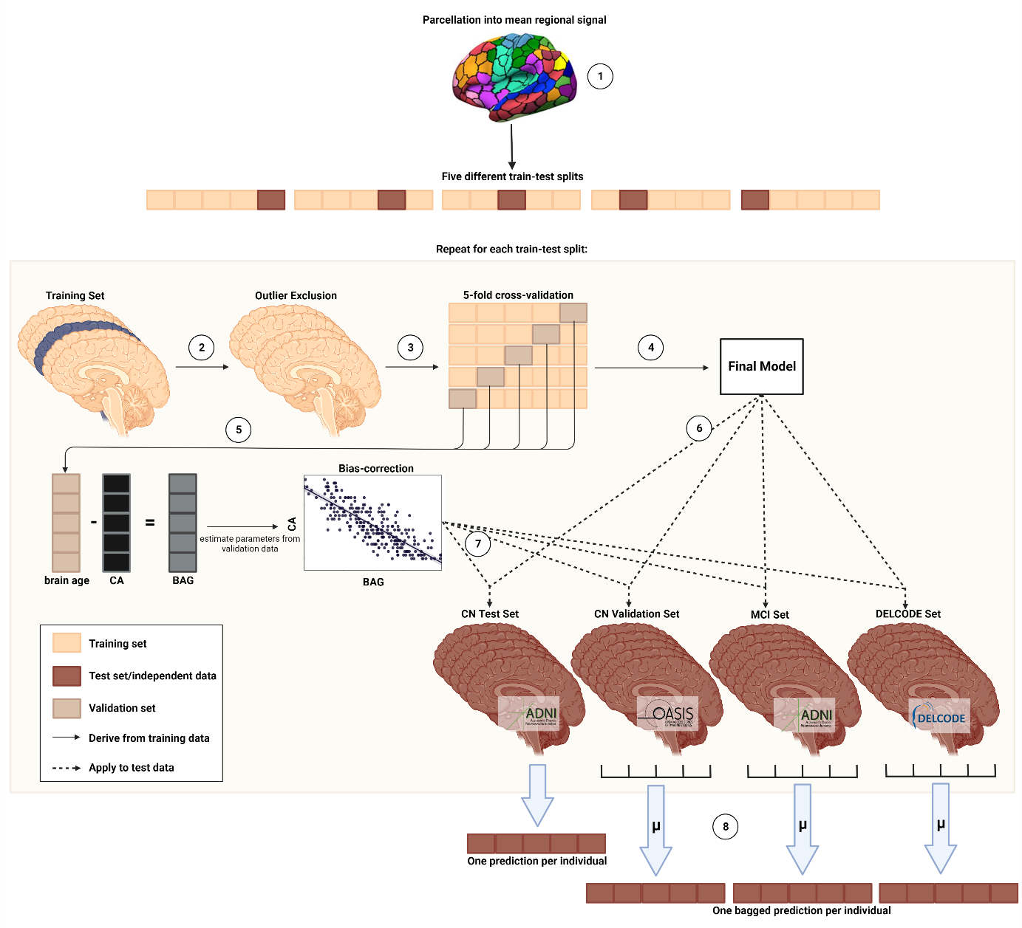**Fig 1. Nested cross-validation approach for brain age prediction.** Five different train-test splits were used to train and test the models. (1) Mean regional gray matter volume or SUVr were inferred from a composite atlas. (2) Outlier exclusion ranges were inferred from the training data, and applied to both the training and test data. (3) Models were trained using five-fold cross-validation. (4) The model with the smallest MAE on the validation folds was chosen as the final model. (5) BA and CA from the validation folds was used to derive bias correction parameters. (6) The final model was subsequently applied to the test sets. (7) Bias correction parameters were applied to predictions in the test set. (8) Mean of predictions across five models is considered as final prediction for CN Validation and MCI set. BA = brain age; CA = chronological age; BAG = brain age gap

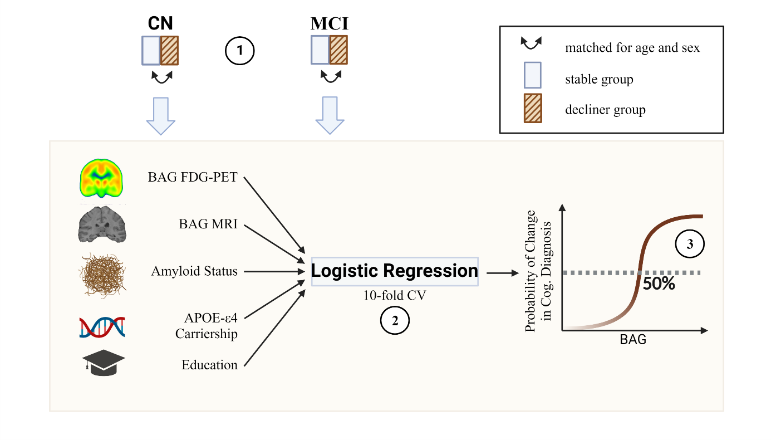

**Fig 2. Estimation of a brain age gap cutoff for cognitive decline.** (1) A stable group was created matched in age and sex to the group of all decliners in CN or MCI. (2) A 10-fold cross-validated prediction of cognitive decline within two years was conducted with FDG-PET and MRI BAG, as well as amyloid status, APOE-ε4 carriership and education as predictors. (3) The BAG cutoff for increased risk of cognitive decline was inferred from a 50% probability of a change in cognitive diagnosis within two years.

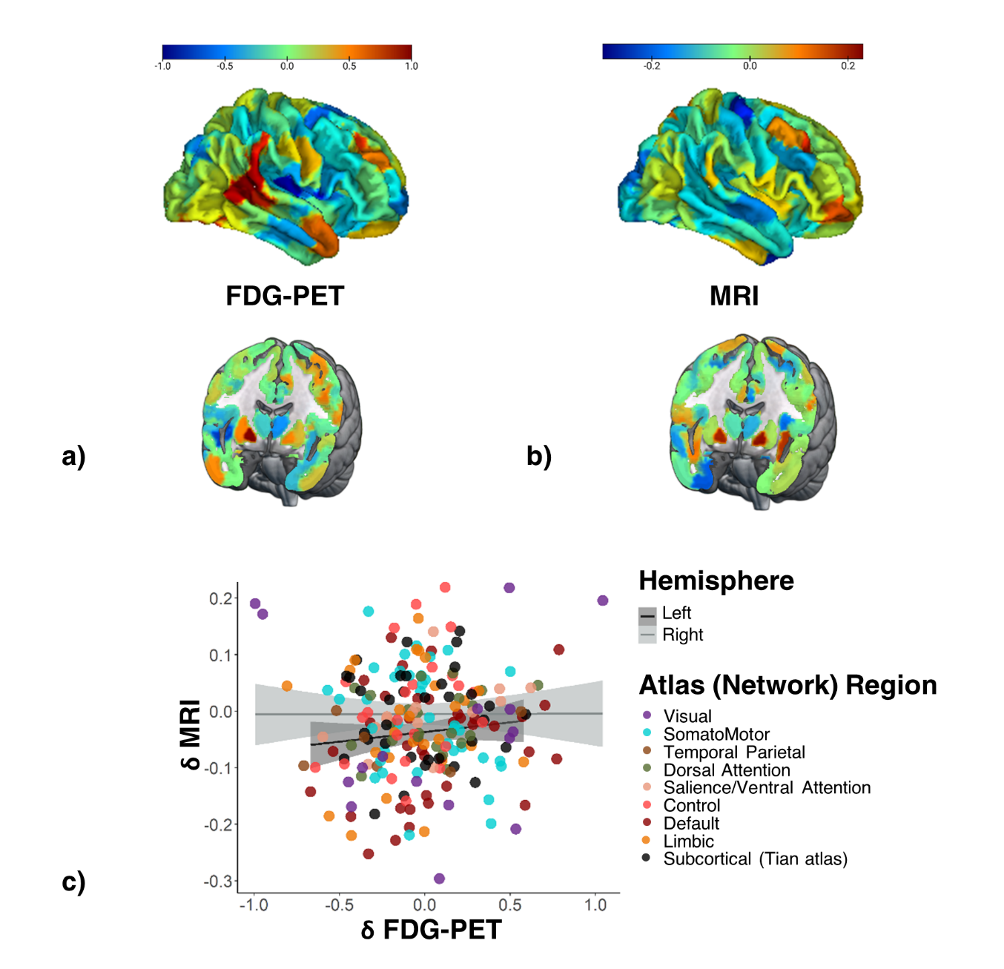

**Fig 3** **Feature importance for brain age prediction.** a) Average weights of support vector regression across three linear SVR for brain age prediction using FDG-PET. Weights were highly correlated across models (r >0.7). b) Average weights of support vector regression across five linear SVR for brain age prediction using MRI. Weights were highly correlated across models (r >0.7). c) Scatter plot of average feature importance in FDG-PET and MRI, as well as regression lines (per hemisphere) show that there is no correlation of feature importance across FDG-PET and MRI. Colors pertain to different brain networks in the Schaefer/Tian atlas.

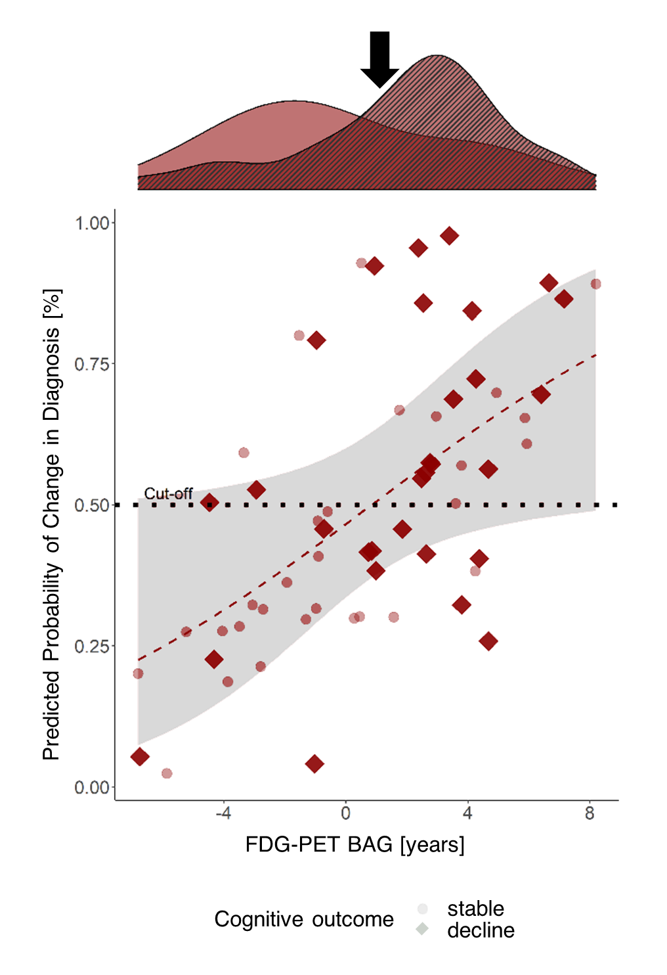

**Fig. 4** **Cross-validated probability of a change in diagnosis from CN/SCD to MCI/dementia within two years by FDG-PET BAG.** Probability was estimated by fitting a logistic regression model on cognitive outcome by FDG-PET BAG, MRI BAG, amyloid status, apoe-e4 carriership and years of education. The red line shows the logistic regression on cognitive outcome by FDG-PET BAG, with the shaded area representing standard error. The red line intersects 50% at 0.85 years BAG on FDG-PET. The density plot above shows FDG-PET BAG distribution of stables (clear) and decliners (striped) in the subsample and the black error points to the cutoff.

**Fig. 5 Cross-validated probability of cognitive decline within two years after a baseline diagnosis of MCI by MRI-BAG.** Probability was estimated by fitting a logistic regression model on cognitive outcome by FDG-PET BAG, MRI BAG, amyloid status, apoe-e4 carriership and years of education. The blue line shows the logistic regression on cognitive outcome by MRI BAG, with the shaded area representing standard error. The blue line intersects 50% at 2.14 years BAG on MRI. The density plot above shows MRI BAG distribution of stables (clear) and decliners (striped) in the subsample and the black error points to the cutoff.

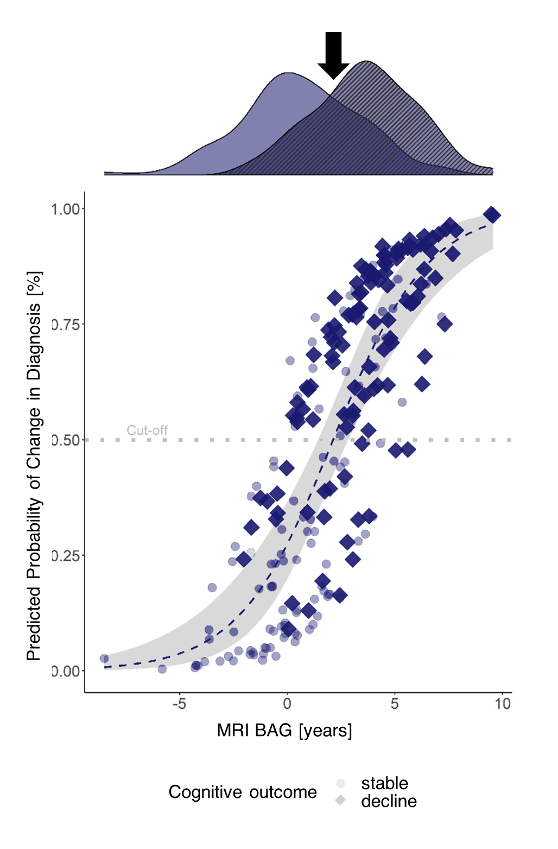

|  |  |  |  |  |  |
| --- | --- | --- | --- | --- | --- |
| **Table 1.** Overview of samples | | | | | |
|  | CN+SCDADNI | CNOASIS | SCDDELCODE | MCIADNI | MCIDELCODE | |
| *n* total | 376 | 59 | 88 | 596 | 80 | |
| Age at PET scan [avg. years (SD)] | 73.9 (5.94) | 71.7**-** (4.22) | 70.9**-** (5.57) | 73.2 (6.93) | NA | |
| Age at MRI scan [avg. years (SD)] | 73.8 (5.92) | 70.36**-** (4.17) | NA | 73.2 (6.92) | 73.4 (5.87) | |
| Sex [%female (nNA)] | 51 (0) | 59 (0) | 41 (0) | 42 (2) | 45 (0) | |
| CSFAβ1-42 Status [%positive (nNA)] | 39 (85) | NA | 43 (28) | 65 (139) | 52 (38) | |
| MMSE [avg. score] | 29 (1.23) | 29 (1.01) | 29**+** (1.03) | 28 (1.75) | 28 (1.67) | |
| Education [avg. years (SD)] | 16 (2.71) | 16 (2.70) | 16**-** (3.00) | 16 (2.67) | 14**-** (3.06) | |
| Notes. Percentage of CSFAβ1-42 Status indicates percentage of amyloid positive individuals among all who received lumbar puncture (excluding NA). Number of individuals who did not receive lumbar puncture for Aβ1-42 is in parentheses. +significantly higher than CN+SCDADNI, -significantly lower than CN+SCDADNI. Comparisons done within modality and group, via t-test for numeric, and χ² for categorical variables, with α = 0.05. | | | | | | |

|  |  |  |  |  |  |  |  |  |
| --- | --- | --- | --- | --- | --- | --- | --- | --- |
| **Table 2.** Precision of predicting chronological age from FDG-PET and MRI scans. | | | | | | |  |  |
|  | CN+SCDADNI | | CNOASIS | | MCIADNI | | SCDDELCODE | MCIDELCODE |
|  | MRI | FDG | MRI | FDG | MRI | FDG | FDG | MRI |
| *n* total | 357⁺ | 357⁺ | 52⁺ | 52⁺ | 596 | 596 | 88 | 80 |
| MAE | 1.96 | 2.63 | 2.23 | 2.03 | 2.62 | 2.51 | 2.64 | 2.62 |
| Range | [-6.91, 9.09] | [-8.72, 9.98] | [-5.44, 7.40] | [-6.70, 5.46] | [-9.07, 9.55] | [-10.91, 9.23] | [-5.49, 7.92] | [-4.64, 9.60] |
| ME | 0.05 | -0.001 | -0.71 | -0.04 | 1.51 | 1.07 | 2.07 | 1.42 |
| R² | .816 | .693 | .593 | .617 | .773 | .794 | .641 | .676 |
| *Notes.* +After outlier exclusion using CN train set (IQR > 6). Precision of bagged predictions are shown for all but the CN+SCDADNI samples. | | | | | | | | |

1. Data used in preparation of this article were obtained from the Alzheimer's Disease Neuroimaging Initiative (ADNI) database (adni.loni.usc.edu). As such, the investigators within the ADNI contributed to the design and implementation of ADNI and/or provided data but did not participate in analysis or writing of this report. A complete listing of ADNI investigators can be found at: <http://adni.loni.usc.edu/wp-content/uploads/how_to_apply/ADNI_Acknowledgement_List.pdf>
2. Mean and standard deviation indicated from absolute difference in days